Summary

Aim: Use Sparse Auto Encoders to identify the features underlying the data.

MEG measures the magnetic field created when neurons are fired. However, MEG data is difficult to measure due to low SNR. They decode the semantic content in the MEG as the subject reads the noun.

They also impose sparsity constraint i.e limiting the no.of nodes in the hidden layer activated by the input pattern. By doing so, we limit the input to the feature space, thereby compressing the data. The activation function is given by:

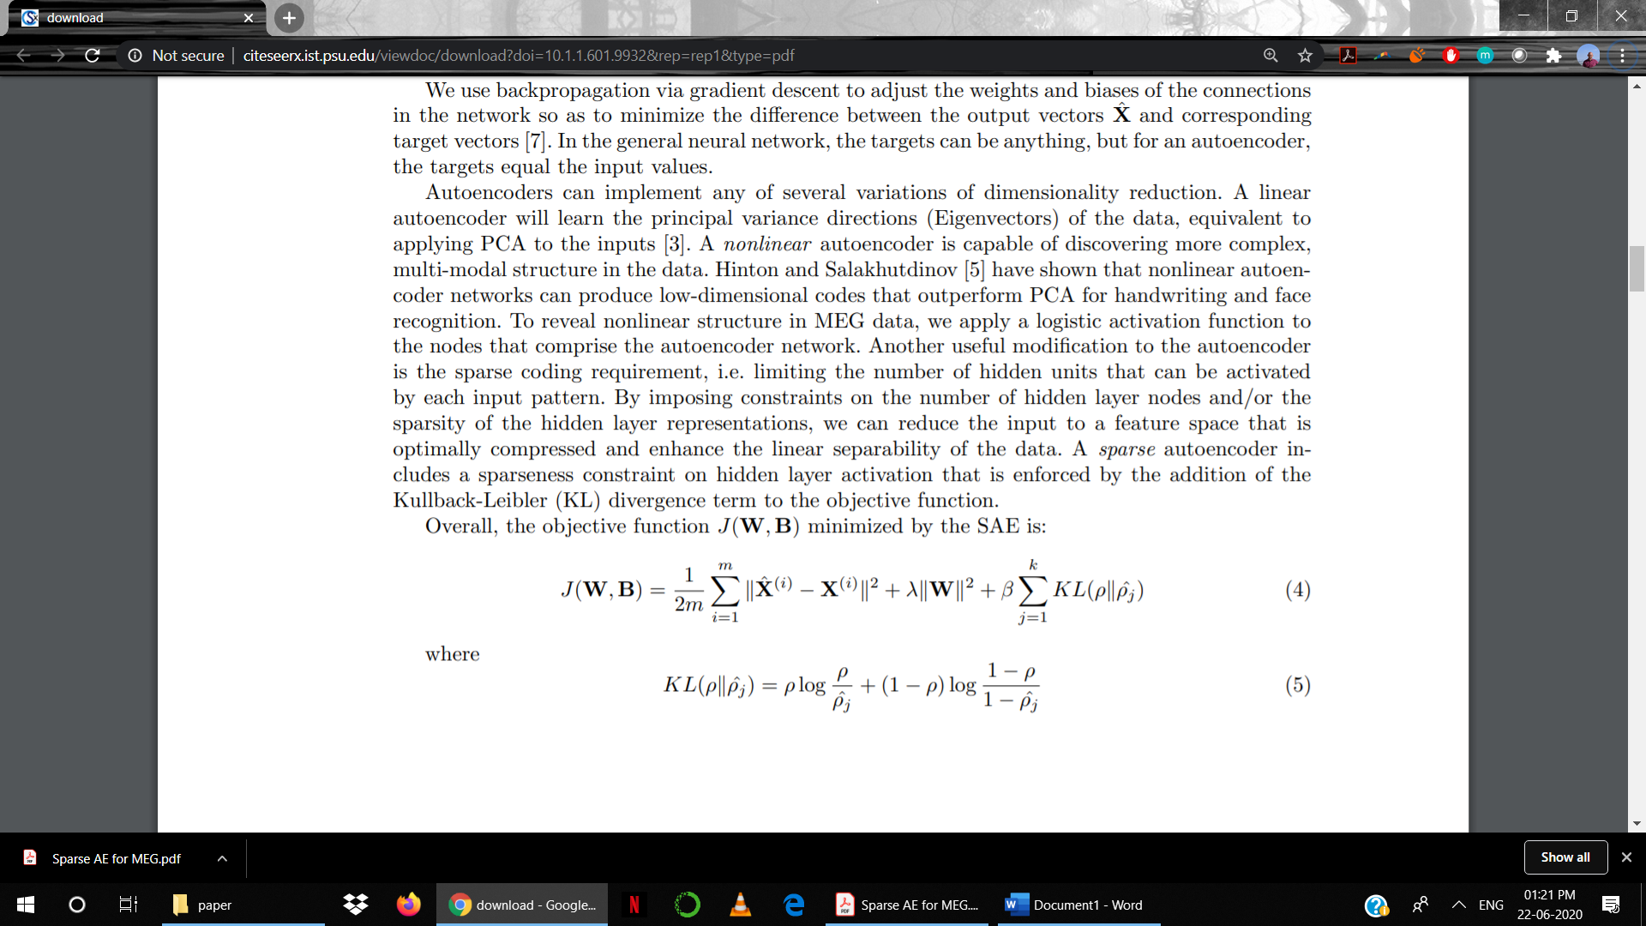

indicates the frequency of activation of hidden nodes. j represents the average thresholded activation of node j over all the training examples.

**Dataset**

Data is collected from 9 subjects who each viewed 60 nouns. Sensor space consists of 150 time samples for each of 306 channels. We also have a 218 semantic vector for each of the 60 words.

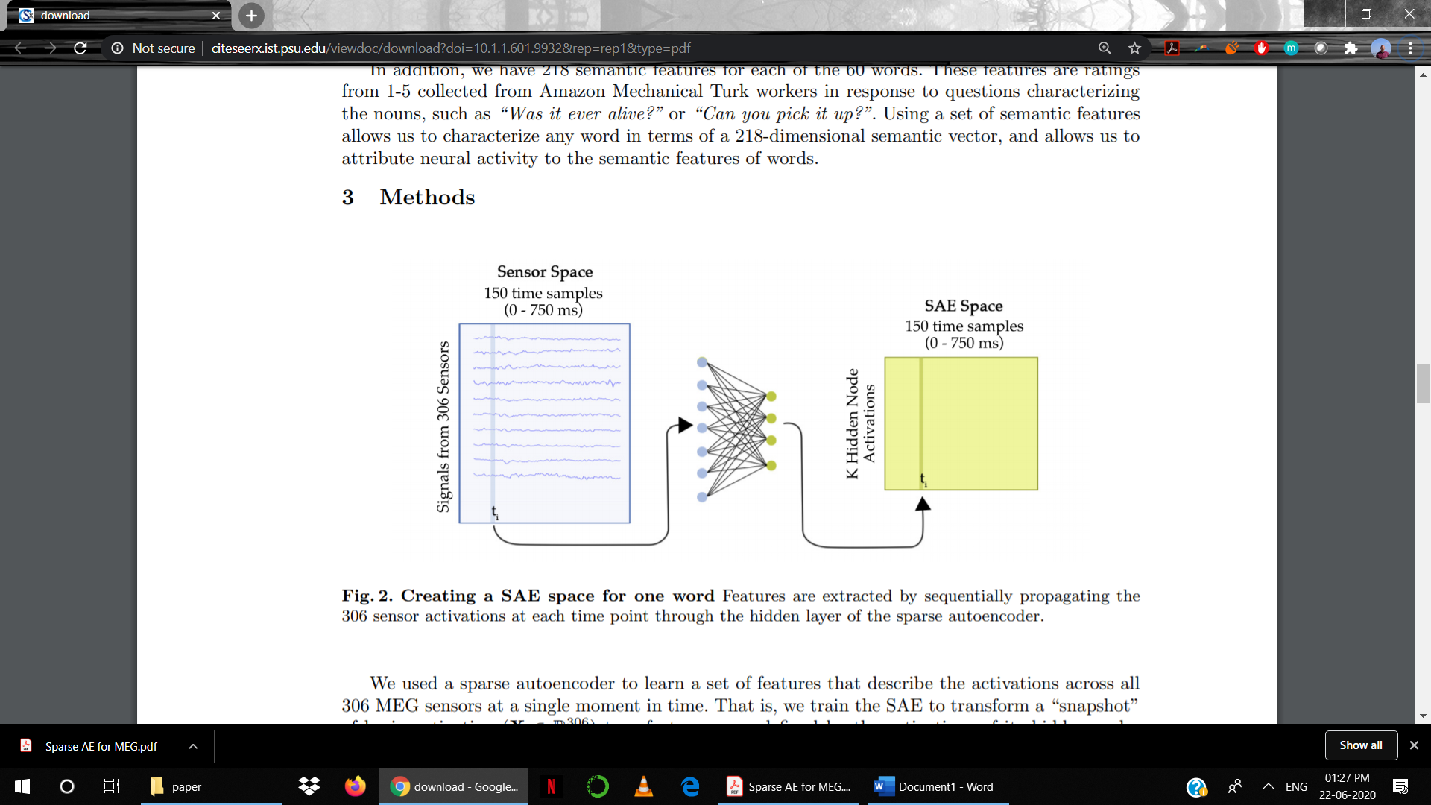

We compare the decoding of the sensor representation to that of SAE representation to see their relative performance.